PROJECT REPORT
On
Watch Management System

Submitted By
Gohel Chirag P.

Project Guide
PROF. KISHORSINH VALA


Submitted To
Geetanjali College of Computer Science
and Commerce (B.B.A.)
Rajkot.

Academic Year
2026–27

Acknowledgement
I Am Happy To Submit My Idea Of "Watch Management System" Application In Saurashtra University, Rajkot For BCA Degree In Computer Branch.
I Also Grateful to Prof. Brijesh Shah, Head Of The Department And All The Faculty Members Of The Department Of Computer Science For Their Kind Support Throughout This Journey.
I Take The Privilege To Acknowledge The Elite Authors Of Numerous Books And Papers And Blogs Which We Have Referred During Progress Of This.
I Also Say The Big Thank You To My Parents For Such A Support And Without Them I Can Do Nothing Not In Just Project But Also In Life. Thankful To My Family For Their Support.
The Feeling Of Gratefulness To Any One's Help Directly Arises From The Bottom Of Heart. A Small But An Important And Timely Help Can Prove To Be A Milestone In One's Life.
Very Thankful To Almighty Of All Of "God" To Give Me Such A Best Person And All The Things He Provides Before I Need And I Always Feel That Without Him I Are Nothing.

Index

Project Profile

Project Title | Watch Management System
Development Software | Visual Studio Code
Front End | HTML, CSS, JS, Bootstrap, Ajax
Back End | Php, MySQL
Academic Year | 2026-27
Developed By | Gohel Chirag P.
Submitted By | Geetanjali Group Of College, Rajkot
Documentation Tools | Ms Word
Operating System | User side : Any os with web browser
Language | HTML, CSS, JS, PHP

System Development Life Cycle

For The Development Of This Project I Have Followed The Simple Waterfall Model Of SDLC.
The Waterfall Model Was The First Process Model To Be Introduced. It Is Also Referred To As A Linear-Sequential Life Cycle Model. It Is Very Simple To Understand And Use. In A Waterfall Model, Each Phase Must Be Completed Before The Next Phase Can Begin And There Is No Overlapping In The Phases.
The Waterfall Model Is The Earliest SDLC Approach That Was Used For Software Development.
The Waterfall Model Illustrates The Software Development Process In A Linear Sequential Flow. This Means That Any Phase In The Development Process Begins Only If The Previous Phase Is Complete. In This Waterfall Model, The Phases Do Not Overlap.
Steps :
- Requirement Gathering
- Project Planning
- Design
- Coding & Implementation
- Testing
1 - Requirement Gathering
Any Software Development Process Must Include The Requirement Gathering Stage. After Choosing The Project Topic, One Must Research Every Criteria Needed To Construct That Specific Project.
I Began Gathering Requirements For My Watch Management System From The Various Online Watch Selling Websites Available In The Market. In Order To Learn About The Necessary Functionality Needed For An E-Commerce Website, I Have Examined Websites Like Titan, Fastrack And Amazon Fashion For Layout And Design Requirements.
Features That Are Needed In Application For User Are As Follows :
- Registration & Login :
Registration & Login Is The Main Feature That Allows A New User To Create An Account And Existing Users To Access Their Account Securely.
- Home Page :
Home Page Is The Feature That Displays The Featured Collection And New Arrivals To The User As Soon As They Visit The Website.
- Products Page :
Products Page Is The Feature That Displays All The Available Watches, Along With Filter, Search And Category (Male/Female) Wise Browsing Options.
- Product Details :
This Feature Allows The User To View Complete Details Of A Selected Watch Including Available Stock, And Add The Desired Quantity To The Cart.
- Cart :
Cart Is The Feature That Will Be Used To Show All The Watches Added By The User, With An Option To Remove Items Or Proceed To Checkout.
- Checkout & Payment :
This Feature Allows The User To Add Delivery Address, View Order Summary And Complete The Order Using The Available Payment Option (Cash On Delivery).
- My Orders :
My Orders Is The Feature That Will Be Used To Show The Order History Of The User, Along With Order Details, Invoice Viewing And Invoice Printing.
- Profile Management :
This Feature Allows The User To View And Update Their Profile Details Such As Username, Email And Phone Number. A Premium Customer Badge Is Also Displayed For Loyal Users.
Features That Are Needed In Application For Admin Are As Follows :
- Dashboard :
It Is The Feature That Will Be Used To Show The Overall Summary Of The Website Including Total Users, Total Orders, Total Watches, Revenue And Recent Orders.
- Add Watch :
This Feature Allows The Admin To Add A New Watch By Filling In The Required Details.
- Manage Watch :
This Feature Allows The Admin To View All Watches In A Table Format And Update Or Delete Any Watch.
- Orders Management :
This Feature Allows The Admin To View, Search And Filter All Orders, And Update The Order Status (Pending, Shipped, Delivered).
- User Management :
This Feature Allows The Admin To View, Search And Delete Registered Users.
- Reports :
This Feature Allows The Admin To View Daily, Monthly And Yearly Sales Along With The Overall Revenue And Sales Reports.

2 - Project Planning
Making A Project Plan Comes Next, After The Requirement Collection Phase Has Been Completed. The Amount Of Project Modules Must Be Determined, And The Optimal Technology For Development Must Be Selected.
To Create The Existing Project, Choosing Technologies In This Case Means Selecting Front End And Back-End Technology.
HTML, CSS, Javascript And Ajax Are Utilized For This Project's Front-End Technology, To Design The User Interface And Handle Client-Side Interactions Without Reloading The Page.
PHP Is Used As The Server-Side Scripting Language To Handle All The Business Logic, Such As User Authentication, Order Processing And Admin Operations.
MySQL Is Utilized As The Back-End Database To Store All The Data Related To Users, Watches, Orders, Cart And Other Information In A Structured Format.

3 - Design
This Process Can Be Broken Down Into Two Parts: The Preliminary Design And The Final Design. The Project's Basic Layout Is Generated On Paper Or Using Any Design Program During The Preliminary Design Phase, And The Development Team Then Evaluates The Design's Viability.
The Second Phase Is Final Design, In Which The Project's Final Or Nearly Accurate Design Is Constructed After Earlier Concepts Have Been Evaluated For Practicality And Flaws Have Been Identified.

4 - Coding & Implementation
The Actual Application Is Coded In The Chosen Programming Language Following The Collection Of All Requirements, Customer Approval Of The Design, And Feasibility Assessment Of The Project.
The SDLC's Longest Phase Is Regarded As Being This One. To Finish This Level, We Need Various Tools Including IDEs, Browsers, And Backend Tools. For Development, I Selected Visual Studio Code For Writing HTML, CSS, Javascript And PHP Code, Along With XAMPP Server For Running PHP And Managing The MySQL Database.
To Avoid Confusion Throughout The Coding Phase, I Also Adhere To The Following Coding Standards:
Coding Standard :
- Give The Variable Names Based On The Activities In Which They Are Present. For Example, If A Variable Is Present In A Watch Related Function, Its Name Must Begin Or End With A Watch Phrase.
- Whenever An Array Is Constructed, The Array Suffix Is Utilized.
- Database Tables Are Given Names Based Only On The Entity They Represent.
- All Variables And Files Must Have Camel Case Names.
- Functions For Fetching Data From Database Employ Get Prefix.
- Functions For Inserting Or Updating Data Employ Add Or Update Prefix Respectively.
The Application Development Divided To Two Phases, Which Are :
- Database Making :
Database Is Made Based On The Design. It Used MySQL Database Which Consists Of 9 Tables (Admin, Users, Watches, Cart, Orders, Order_Item, User_Addresses, Contact_Messages And Newsletter_Subscribers) That Are Related To Each Other To Manage The Entire Website's Data.
- Website Development :
This Phase Is Translating The Result Of Design Into HTML, CSS And Javascript For The Front-End User Interface, And PHP For The Server-Side Logic Of Both The User Side And The Admin Panel.

5 - Testing
The Application Is Ready To Be Tested For Usability And To See If It Is Operating As Planned Once The Coding And Implementation Phases Are Complete.
For Testing Purpose, I Shared My Website With My Colleagues And Friends To Verify Its Functions And User Friendliness, Such As User Registration, Login, Placing An Order, And Admin Operations Like Adding Watches And Managing Orders.
System Requirement Specifications
To Develop This Project, The Following System Hardware And Software Are Required :
Minimum Hardware Requirement (For Developer) :
Component | Requirement
Operating System | Windows 7 / 10 / 11
CPU/Processor | Intel i3 or above
RAM | 4 GB
Hard Disk | 20 GB Free Space

Software Requirements (For Developer) :
Requirement | Specification
Server | XAMPP / WAMP / Laragon
Database | MySQL
Backend Language | PHP 8.0
Front End | HTML, CSS, JavaScript, AJAX
Code Editor | Visual Studio Code
Browser | Google Chrome / Mozilla Firefox (Latest Version)

Client Side Requirement (For End User) :
Component | Requirement
Device | Computer / Laptop / Smartphone
Browser | Any Modern Web Browser
Internet Connection | Required  Note : When the website is hosted.

About the tools & technologies
VS Code (Visual Studio Code):
Visual Studio Code is a free, open-source source-code editor developed by Microsoft that works with a wide variety of programming languages such as HTML, CSS, JavaScript, PHP, Python, C++, and many more. It is built on the Electron framework and is available for Windows, macOS, and Linux operating systems.
VS Code comes with built-in support for features like IntelliSense (smart code completion), syntax highlighting, code folding, bracket matching, and an integrated terminal, which makes writing and debugging code faster and easier. It also has a rich extension marketplace that allows developers to add support for additional languages, themes, debuggers, and tools like Live Server, PHP Intelephense, and MySQL extensions — all of which were used during the development of this project for faster coding and real-time preview of changes.
HTML (HyperText Markup Language):
HTML is the standard markup language used for creating the structure and layout of web pages. It defines the basic skeleton of a webpage using various tags and elements such as headings, paragraphs, images, tables, forms, and links.
In this project, HTML is used to design the structure of all the pages, including the Home Page, Product Listing, Cart, Checkout, and Admin Panel pages. It works together with CSS and JavaScript to create a complete, functional, and interactive website.
CSS (Cascading Style Sheets):
CSS is used to style and design the visual appearance of a webpage created using HTML. It controls the layout, colors, fonts, spacing, and responsiveness of a website, making it visually appealing and user-friendly across different screen sizes and devices.
In this project, CSS is used to design an attractive and responsive user interface for both the User Side (Home, Products, Cart, Checkout, Profile) and the Admin Side (Dashboard, Manage Watch, Orders, Reports), ensuring a smooth and consistent user experience.
JavaScript:
JavaScript is a lightweight, interpreted programming language primarily used to make web pages interactive and dynamic. It runs on the client side (in the browser) and allows developers to manipulate HTML and CSS in real-time, validate forms, handle events, and create dynamic content without reloading the page.
In this project, JavaScript is used for tasks such as form validation, updating cart quantity, showing/hiding elements dynamically, handling button clicks (like Add to Cart, Update, Delete), and enhancing the overall interactivity of the website.
Bootstrap:
Bootstrap is a popular, open-source front-end framework used to design responsive and mobile-friendly websites. It provides a collection of pre-designed HTML, CSS, and JavaScript components that help developers create attractive and consistent web pages quickly. It includes ready-made elements such as navigation bars, buttons, forms, cards, tables, modals, alerts, and responsive grid systems.
In this project, Bootstrap is used for tasks such as creating responsive layouts, designing navigation bars, styling forms and buttons, displaying product cards, managing tables, creating modals, and ensuring the website looks attractive and works smoothly across different screen sizes and devices.

AJAX (Asynchronous JavaScript and XML):
AJAX is a web development technique that allows a webpage to communicate with the server and update parts of the page without refreshing the entire page. It works by sending and receiving data in the background using JavaScript, which results in a faster and smoother user experience.
In this project, AJAX is used for features like adding products to the cart, updating quantity, updating order status from the Admin Panel, and searching/filtering products and orders — all of which happen instantly without reloading the page, giving the application a smooth and modern feel.
PHP (Hypertext Preprocessor):
PHP is a widely used open-source server-side scripting language designed for web development. It is used to create dynamic and interactive web pages that interact with a database. PHP can handle form data, manage sessions, connect to databases, and generate dynamic content based on user requests.
In this project, PHP acts as the backend of the entire system. It handles user registration and login, product management (add/edit/delete watches), cart and order processing, invoice generation, admin authentication, and all the business logic connecting the frontend with the MySQL database.
MySQL:
MySQL is one of the most popular open-source relational database management systems (RDBMS). It stores data in a structured format using tables, rows, and columns, and uses Structured Query Language (SQL) to insert, update, delete, and retrieve data efficiently.
In this project, MySQL is used to store and manage all the important data such as user details, watch/product information, cart items, orders, order items, addresses, contact messages, newsletter subscribers, and admin details. It ensures that data remains organized, secure, and easily retrievable whenever required by the application.

Data Flow Diagram
User Side :
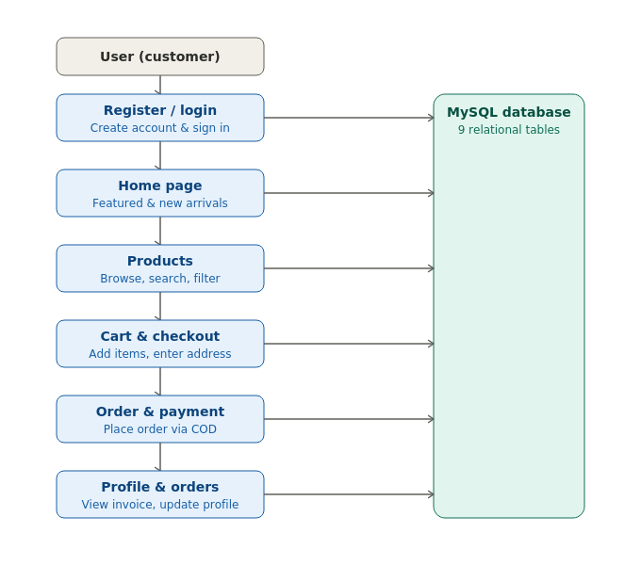

Admin Side :
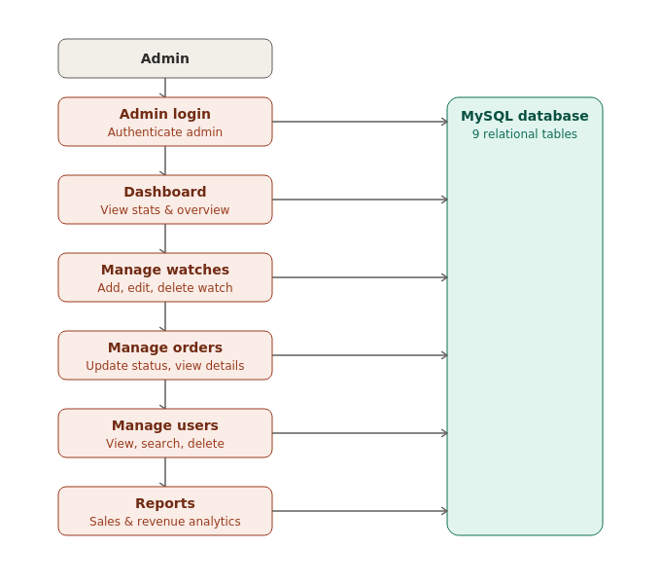

Entity Relationship Diagram
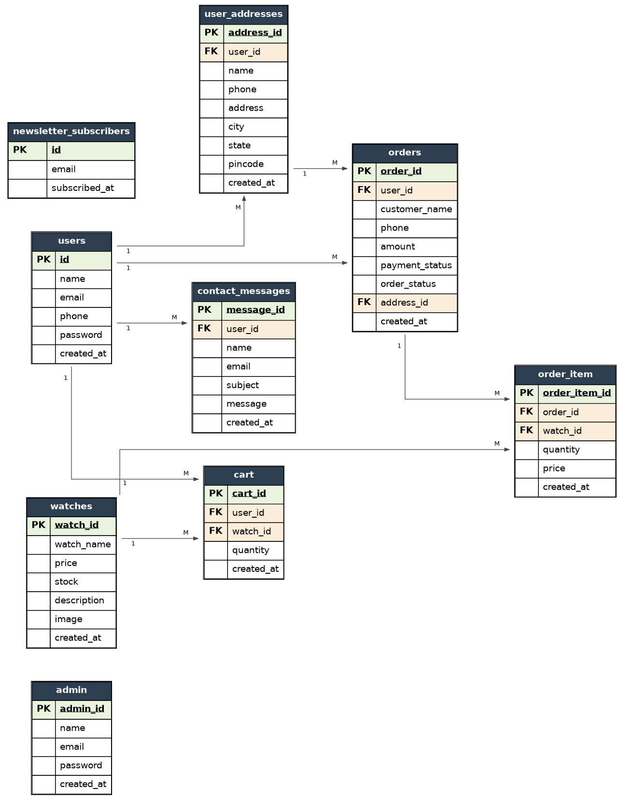

Data Dictionary
1. Admin Table :
Sr no | Field | Data Type | Size | Constraint
1 | admin_id | Int | 11 | Primary Key
2 | name | Varchar | 100 | -
3 | email | Varchar | 100 | Unique
4 | password | Varchar | 255 | -
5 | created_at | Timestamp | - | -

2. Users Table:
Sr no | Field | Data Type | Size | Constraint
1 | id | Int | 11 | Primary Key
2 | name | Varchar | 100 | -
3 | email | Varchar | 100 | Unique
4 | phone | Varchar | 15 | -
5 | password | Varchar | 255 | -
6 | created_at | Timestamp | - | -

3. Watches Table :
Sr no | Field | Data Type | Size | Constraint
1 | watch_id | Int | 11 | Primary Key
2 | watch_name | Varchar | 150 | -
3 | price | Decimal | 10,2 | -
4 | stock | Int | 11 | -
5 | description | Text | - | -
6 | image | Varchar | 255 | -
7 | created_at | Timestamp | - | -

4. Cart Table :
Sr no | Field | Data Type | Size | Constraint
1 | cart_id | Int | 11 | Primary Key
2 | user_id | Int | 11 | Foreign Key
3 | watch_id | Int | 11 | Foreign Key
4 | quantity | Int | 11 | -
5 | created_at | Timestamp | - | -

5. User_Addresses Table :
Sr no | Field | Data Type | Size | Constraint
1 | address_id | Int | 11 | Primary Key
2 | user_id | Int | 11 | Foreign Key
3 | name | Varchar | 100 | -
4 | phone | Varchar | 15 | -
5 | address | Text | - | -
6 | city | Varchar | 100 | -
7 | state | Varchar | 100 | -
8 | pincode | Varchar | 10 | -
9 | created_at | Timestamp | - | -

6. Orders Table :
Sr no | Field | Data Type | Size | Constraint
1 | order_id | Int | 11 | Primary Key
2 | user_id | Int | 11 | Foreign Key
3 | customer_name | Varchar | 100 | -
4 | phone | Varchar | 15 | -
5 | amount | Decimal | 10,2 | -
6 | payment_status | Varchar | 50 | -
7 | order_status | Varchar | 50 | -
8 | created_at | Timestamp | - | -
9 | address_id | Int | 11 | Foreign Key

7. Order_Item Table :
Sr no | Field | Data Type | Size | Constraint
1 | order_item_id | Int | 11 | Primary Key
2 | order_id | Int | 11 | Foreign Key
3 | watch_id | Int | 11 | Foreign Key
4 | quantity | Int | 11 | -
5 | price | Decimal | 10,2 | -
6 | created_at | Timestamp | - | -

8. Contact_Messages Table :
Sr no | Field | Data Type | Size | Constraint
1 | message_id | Int | 11 | Primary Key
2 | user_id | Int | 11 | Foreign Key
3 | name | Varchar | 100 | -
4 | email | Varchar | 100 | -
5 | subject | Varchar | 150 | -
6 | message | Text | - | -
7 | created_at | Timestamp | - | -

9. Newsletter_Subscribers Table :
Sr no | Field | Data Type | Size | Constraint
1 | id | Int | 11 | Primary Key
2 | email | Varchar | 100 | Unique
3 | subscribed_at | Timestamp | - | -

Screen Shots
User Side Screens :

1. welcome.php Page (welcome.php) :

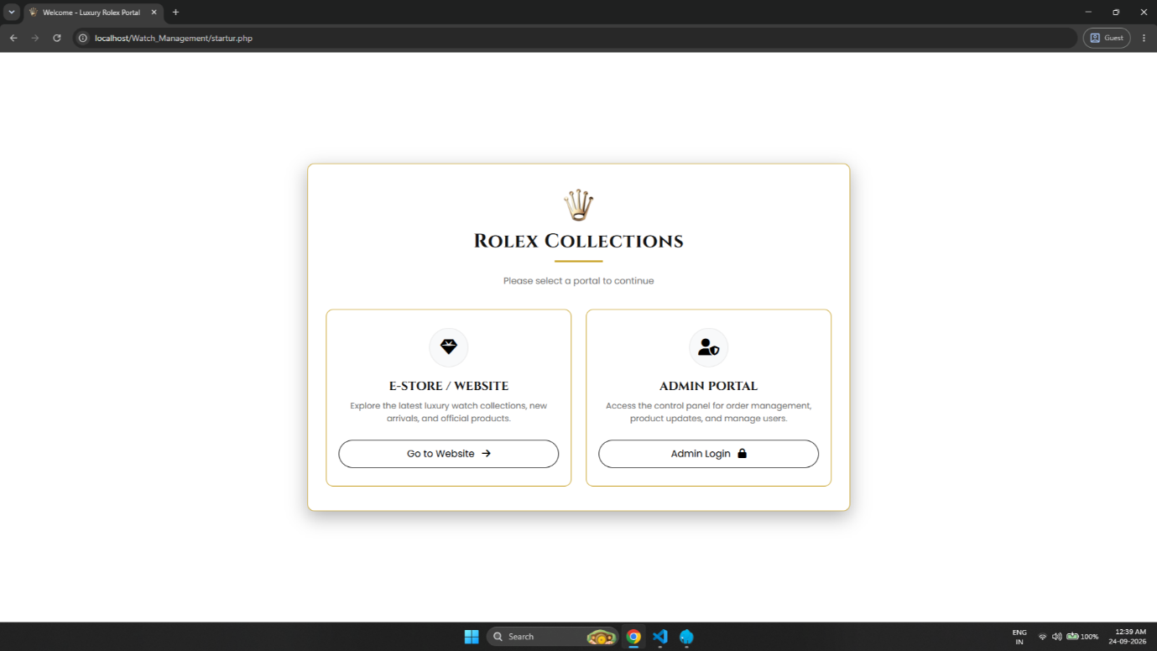

- Welcome Portal : Users can select between the E-Store/Website and Admin Portal.
- Portal Access : E-Store provides access to watch collections, while Admin Portal provides access to order management, product updates and user management.

2. Register Page (register.php) :

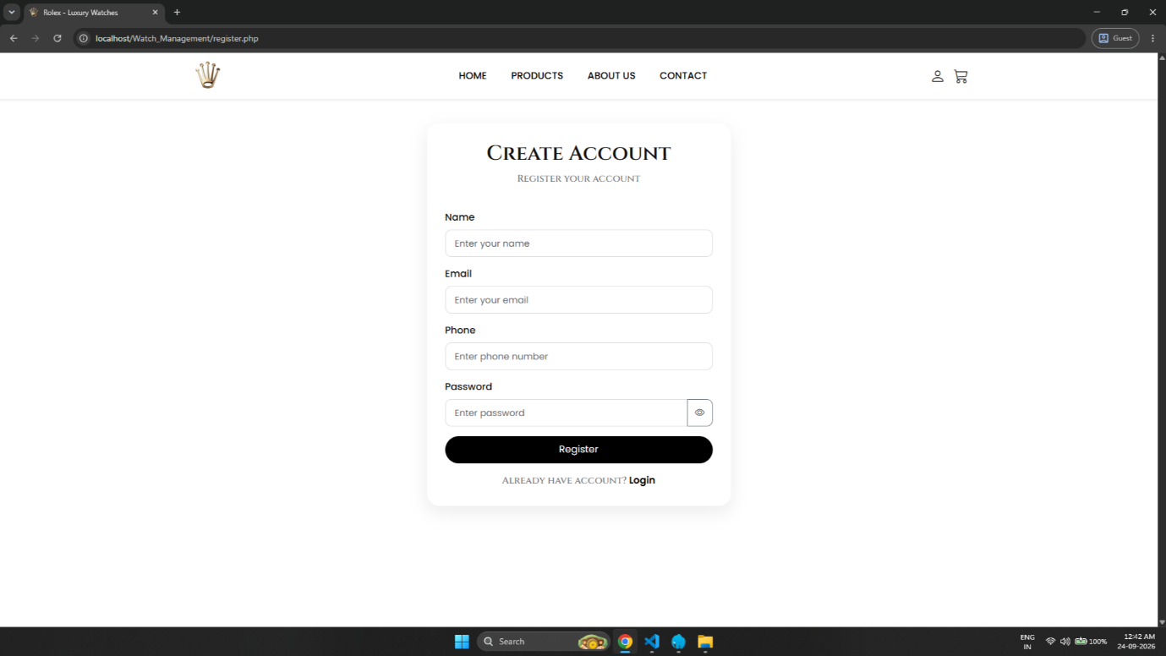

- This is the first screen for a new customer.
- The customer creates a new account by entering Name, Email, Phone and Password.

- Login Page (login.php) :

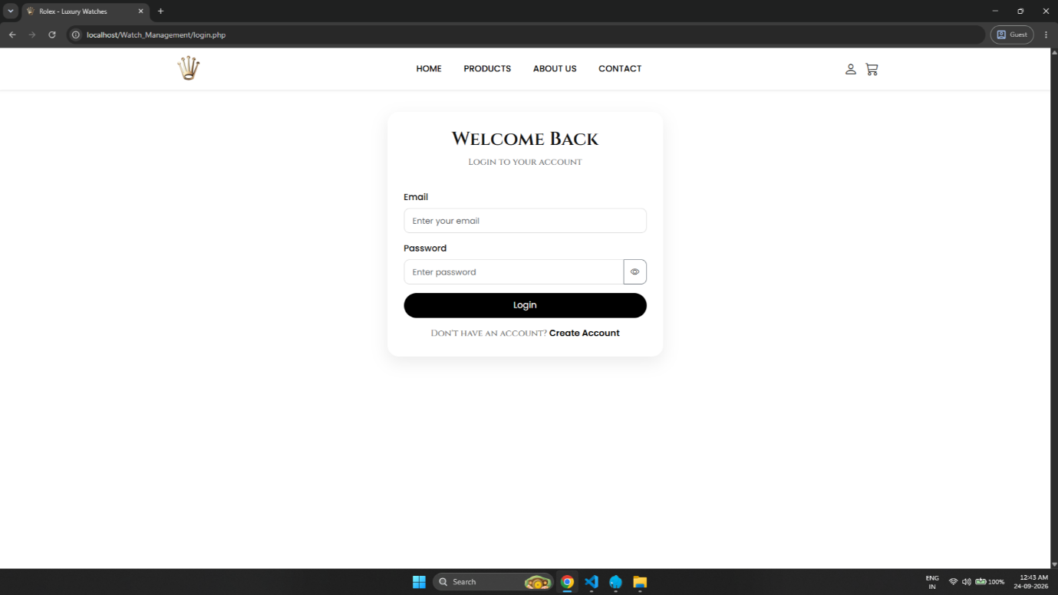

- Existing customers log in to their account using their registered Email and Password.
- A link is provided to navigate to the Register page for new customers.
- This is a unified Authentication/Login page allowing both users and administrators to securely access their accounts from a single location. It consists of email and password input fields with validation and a link for new users to create a new account.
4. Home Page (index.php) :
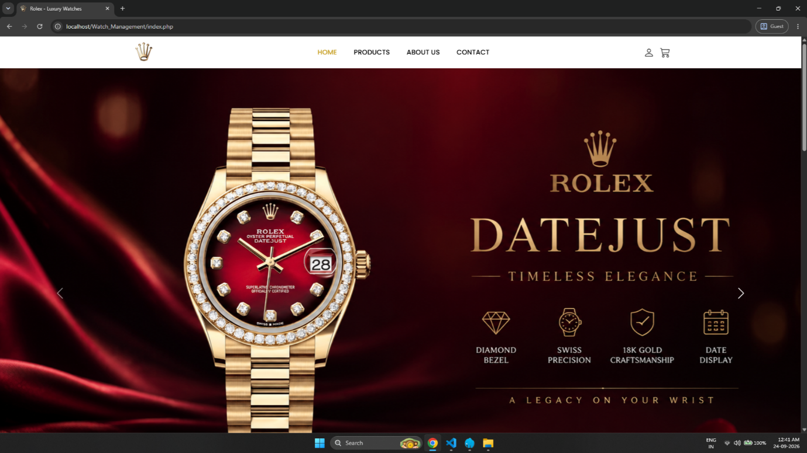

- This is the main landing page (index.php) of the website, featuring an attractive hero slider displaying premium watches.
- It showcases the "Featured Collection" section, allowing users to view highlighted watch models along with their prices, ratings, and details.

5. Products Page (products.php) :
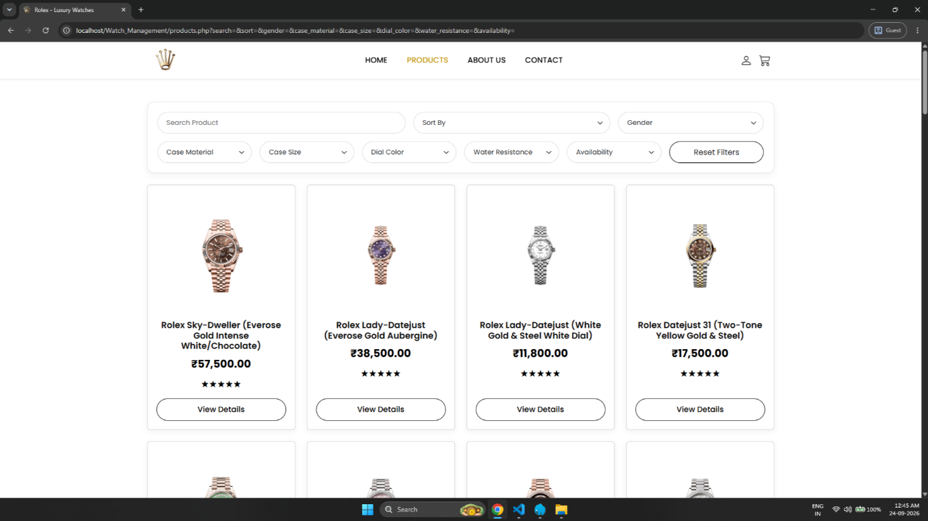

- This is the Products page where users can browse the complete collection of watches with their titles, prices, and ratings.
- It provides advanced search, sorting, and multi-criteria filters (like Case Material, Case Size, Dial Color, and Availability) to easily refine the product catalog.

6. Product Details Page (product-details.php) :
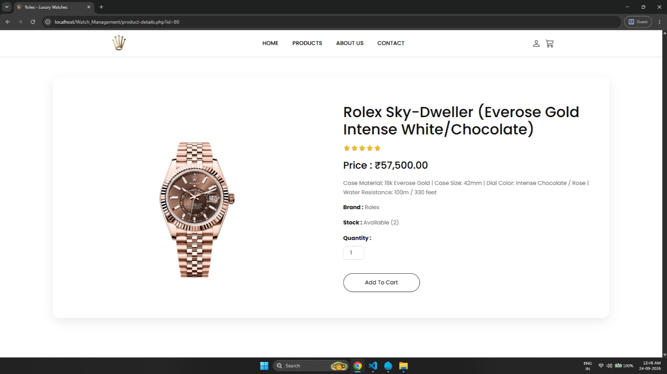

- This is the Product Details page displaying comprehensive watch specifications including price, stock status, ratings, and material details.
- It allows users to select the desired quantity and add the product directly to their shopping cart.
7. Cart Page (cart.php) :
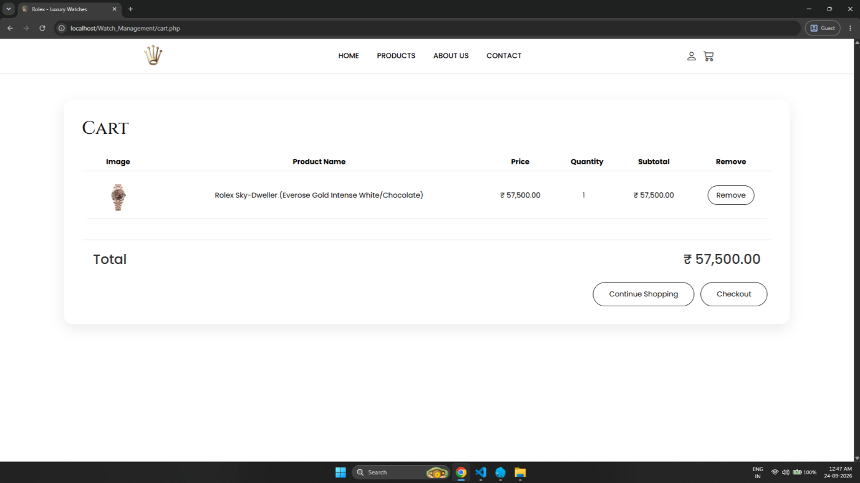

- This is the Cart page where users can review all selected products along with their images, prices, quantities, and subtotal amounts.
- It allows users to remove unwanted items, view the final total price, and proceed to the checkout page using the "Checkout" button.
8. Checkout Page (checkout.php) :
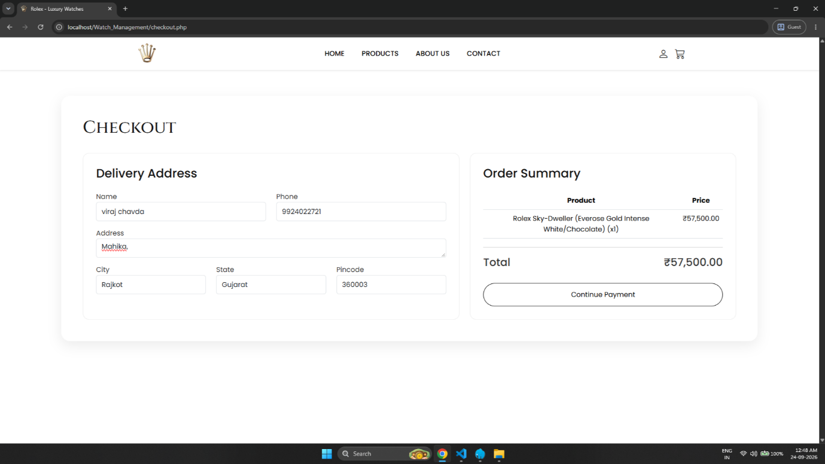

- This is the Checkout page where users fill in their delivery details, including name, contact number, and full shipping address.
- It displays a concise "Order Summary" on the side, allowing users to verify their order details and total amount before proceeding to payment.
9. Payment Page (payment.php) :
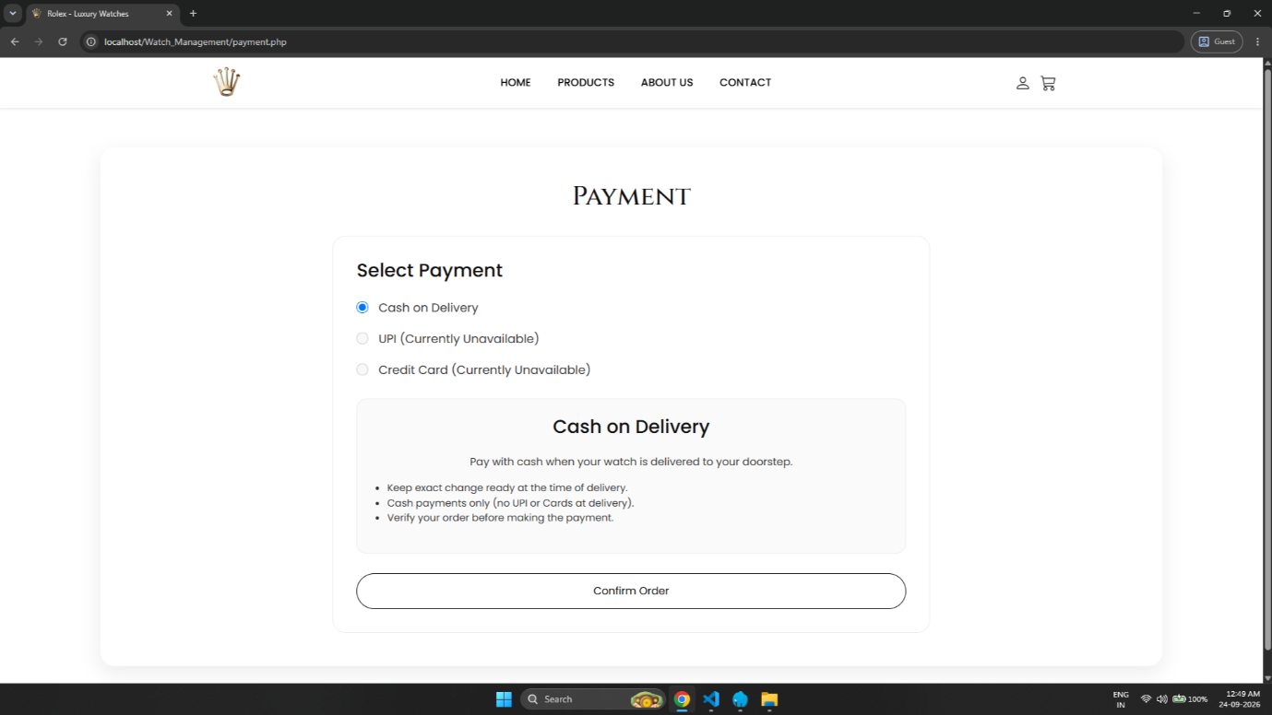

- This page allows users to select their preferred payment method to complete the purchase transaction.
- Currently, it highlights Cash on Delivery (COD) as the primary option with clear instructions, alongside placeholder options for UPI and Cards.
10. Order Confirmation Page (order-sucess.php) :
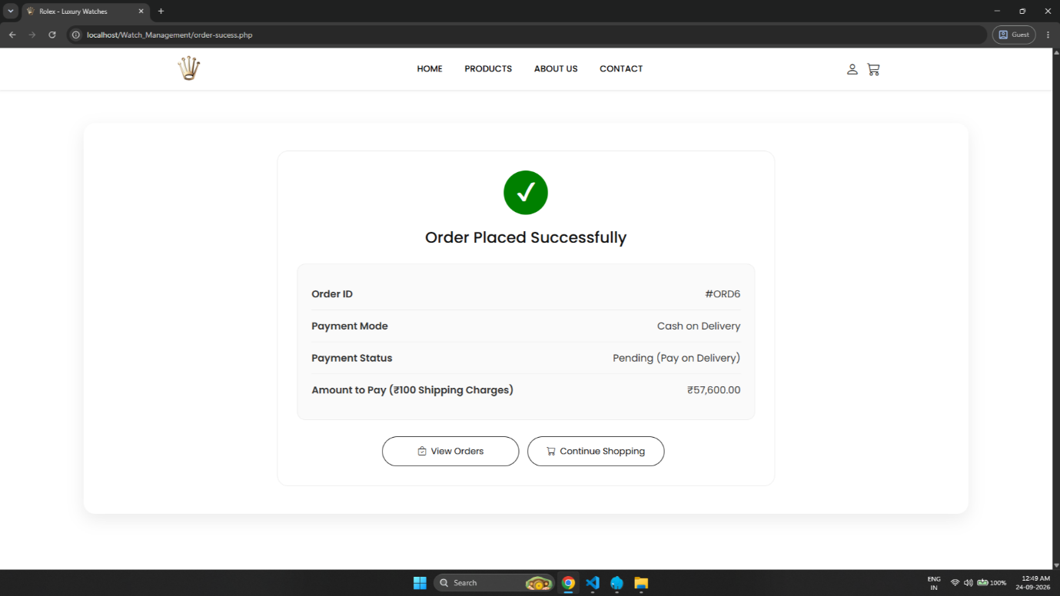
- This is the Order Confirmation page displayed immediately after a successful order placement, providing a summary of the order.
- It shows the generated Order ID (#ORD4), selected payment mode, payment status, total payable amount, and direct links to view orders or return home.
11. My Orders Page (my-orders.php) :
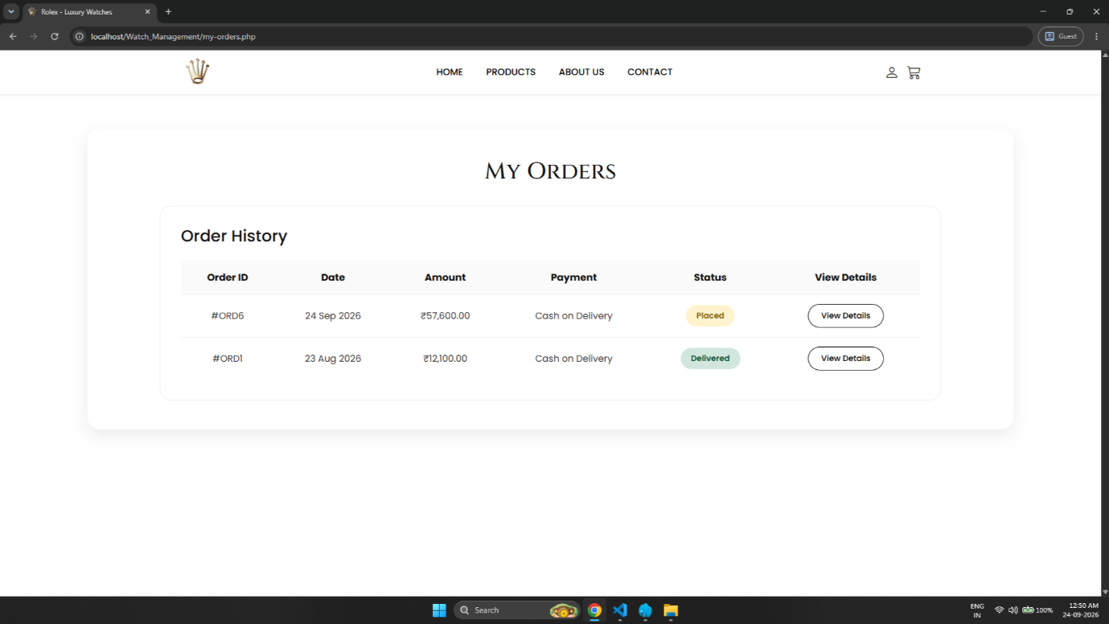
- This is the My Orders page where registered users can view their complete order history.
- It lists past orders in a structured table format with Order ID, purchase date, total amount, payment method, current status, and a button to view specific order details.

12. Order Details Page (order-details.php) :
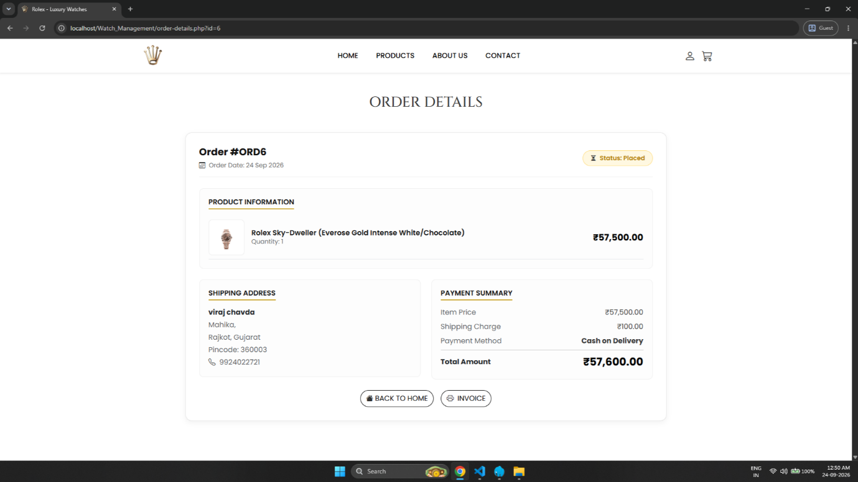

- This page displays in-depth details for a specific selected order, including product itemization, shipping address, and payment summary.
- It features actionable options to return to the home page or directly generate and view the official invoice using the "Invoice" button.
13. Invoice Page (invoice.php) :
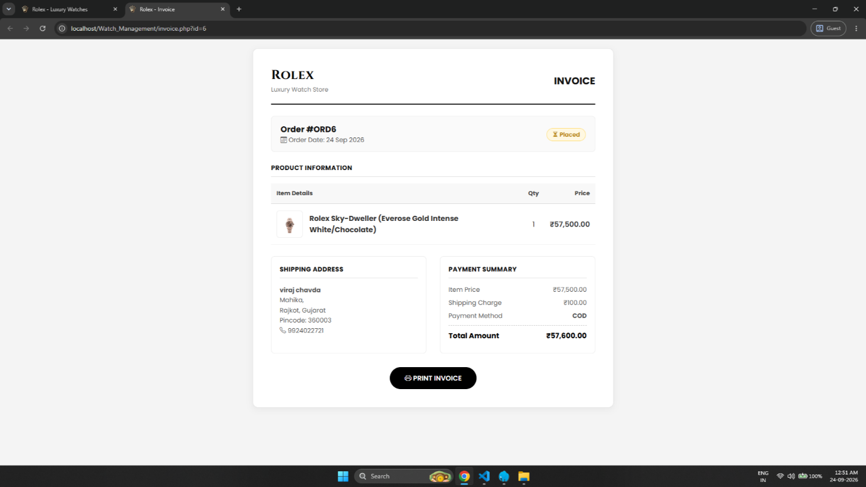

- This is the digital Invoice page generated for completed orders, formatted as a formal billing document.
- It contains complete store branding, order ID, purchase date, item descriptions, shipping details, and a dedicated button to print the invoice.
14. Invoice Print Preview Page (invoice-print.php) :
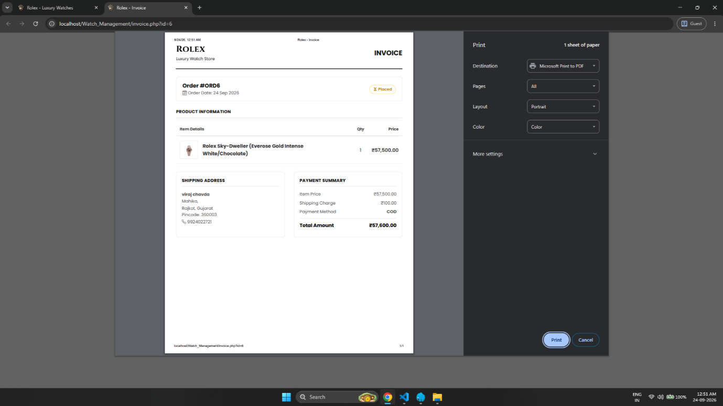

- This is the system print preview layout triggered when a user clicks to print or download the invoice.
- It allows users to export the invoice directly as a PDF or send it to a connected printer with customized layout settings.
15. Profile Page (profile.php) :
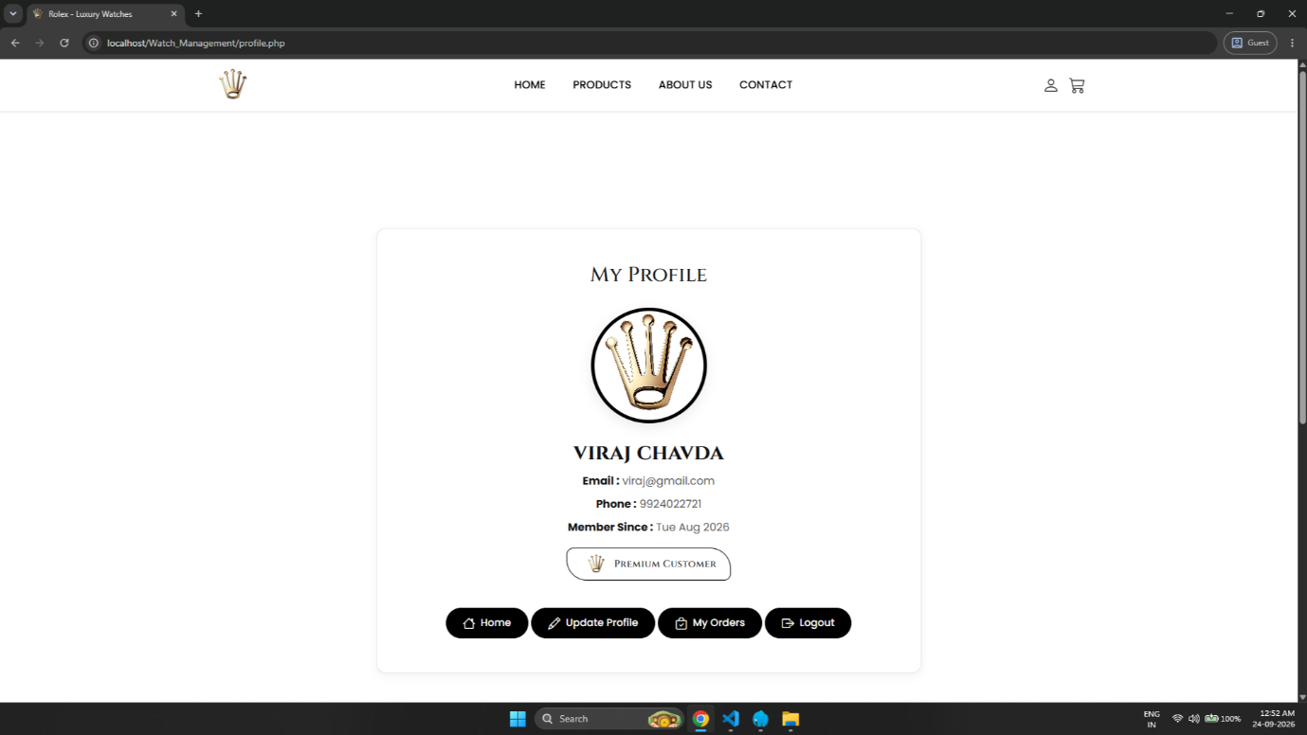

- This is the My Profile page displaying the logged-in user's personal account information, including name, email address, phone number, and membership date.
- It provides quick navigation buttons to update profile details, view order history, return home, or safely log out of the system.

Admin Side Screens :
16. Admin Login Page (login.php) :
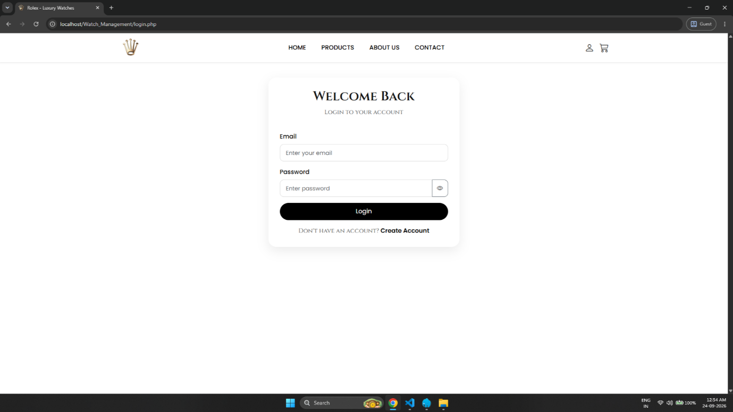

- This is a unified Authentication/Login page allowing both users and administrators to securely access their accounts from a single location. It consists of email and password input fields with validation and a link for new users to create a new account.
17. Dashboard Page (dashboard.php) :
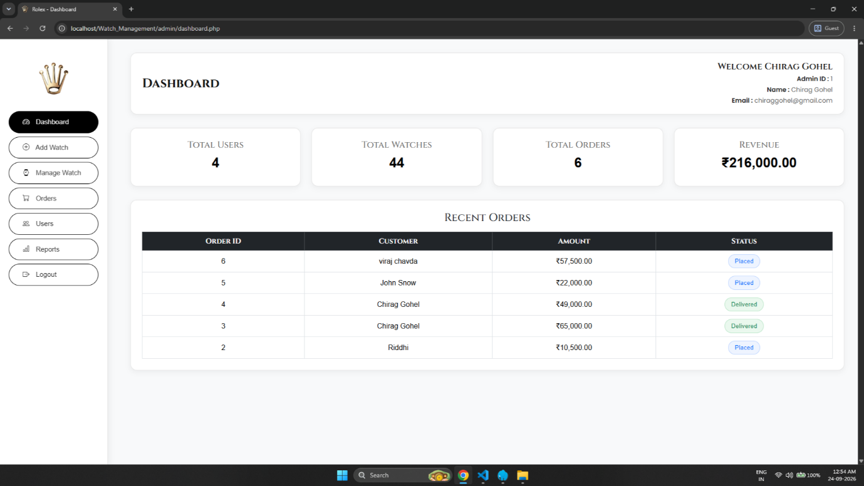
- This is the main Administrative Dashboard panel, providing an overview of system metrics including Total Users, Total Watches, Total Orders, and Overall Revenue.
- It displays a 'Recent Orders' table showcasing real-time order status updates (Pending, Processing, Shipped, Delivered) for quick administrative tracking.
18. Add Watch Page (add-watch.php) :
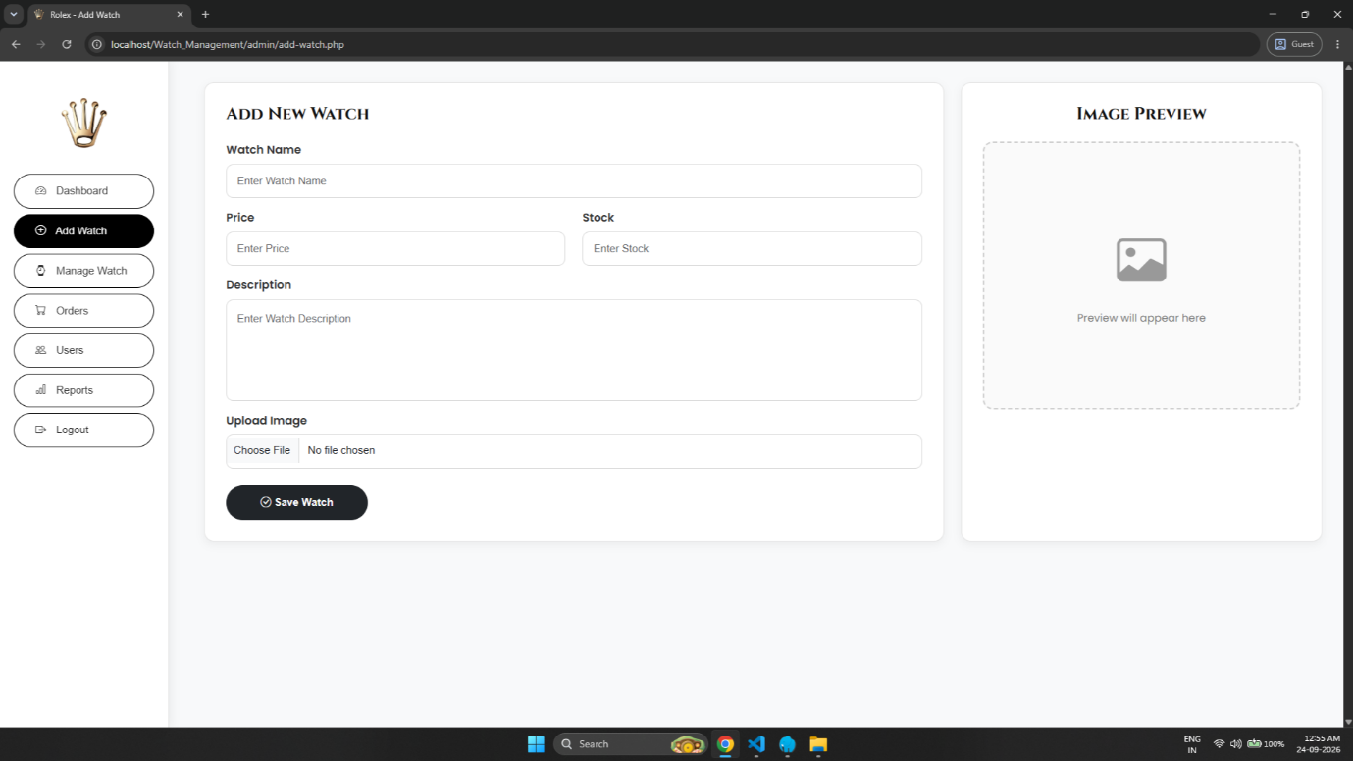
- This page provides an entry form for administrators to add new watches by entering details like Name, Price, Stock, Description, and uploading product images.
- It includes a real-time 'Image Preview' box on the side to display the uploaded watch image before saving it to the database.
19. Manage Watch Page (manage-watch.php) :
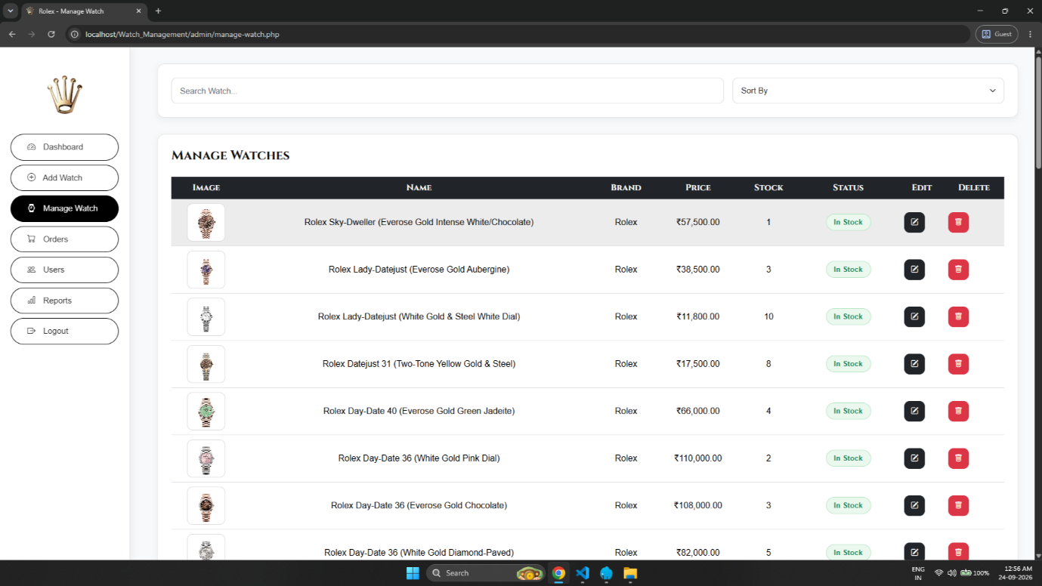

- This module provides a complete product inventory table displaying watch images, names, prices, stock levels, and current stock status (In Stock / Out of Stock).
- It features search and sorting controls along with direct action buttons to Edit or Delete individual watch items from the system.
20. Orders Page (orders.php) :
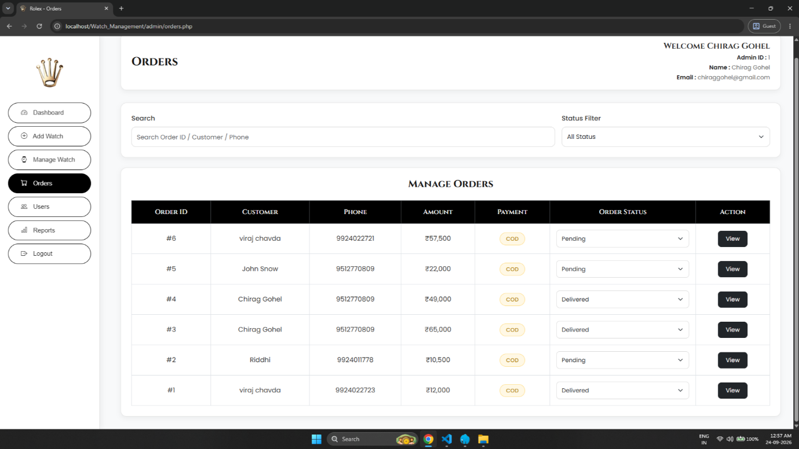
- This interface lists all customer orders with key details such as Order ID, Customer Name, Contact Number, Order Amount, Payment Method, and current Order Status.
- It enables administrators to search and filter orders by status, as well as update order statuses directly via dropdown controls and access detailed views.
21. Order View Page (order-details.php) :
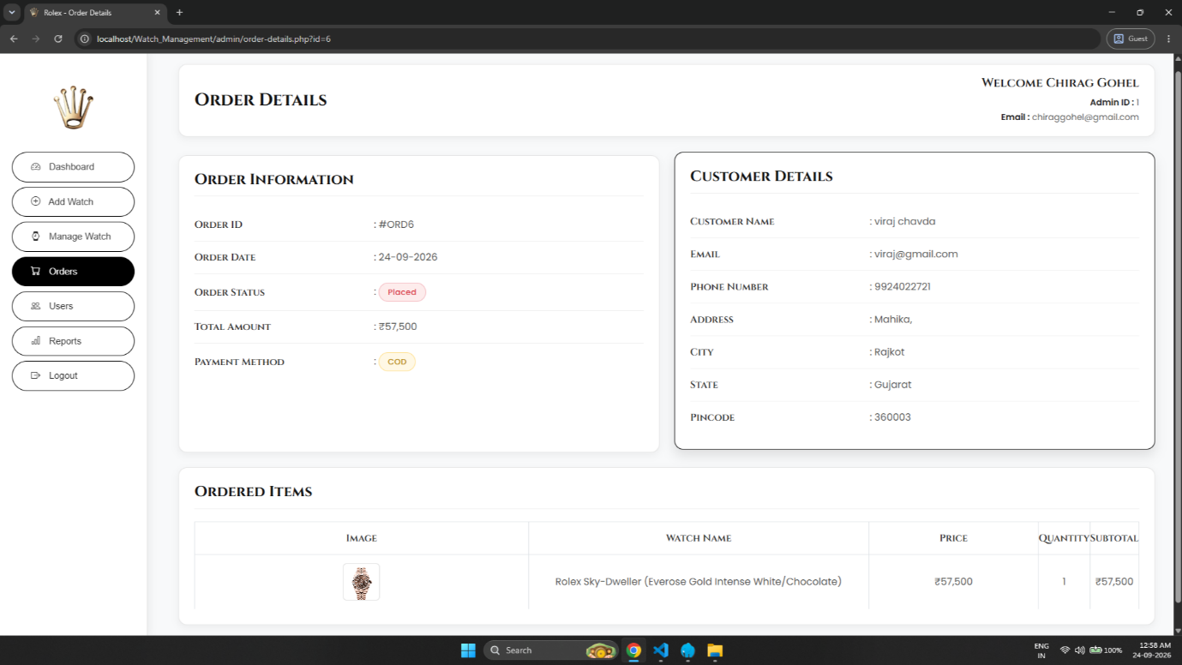

- This page provides a comprehensive detailed breakdown of a specific order, including Order Information, Payment Details, and Customer Shipping/Contact Info.
- It features an 'Ordered Items' section displaying product previews, unit prices, purchased quantities, and final calculated subtotals.

22. Users Page (users.php) :
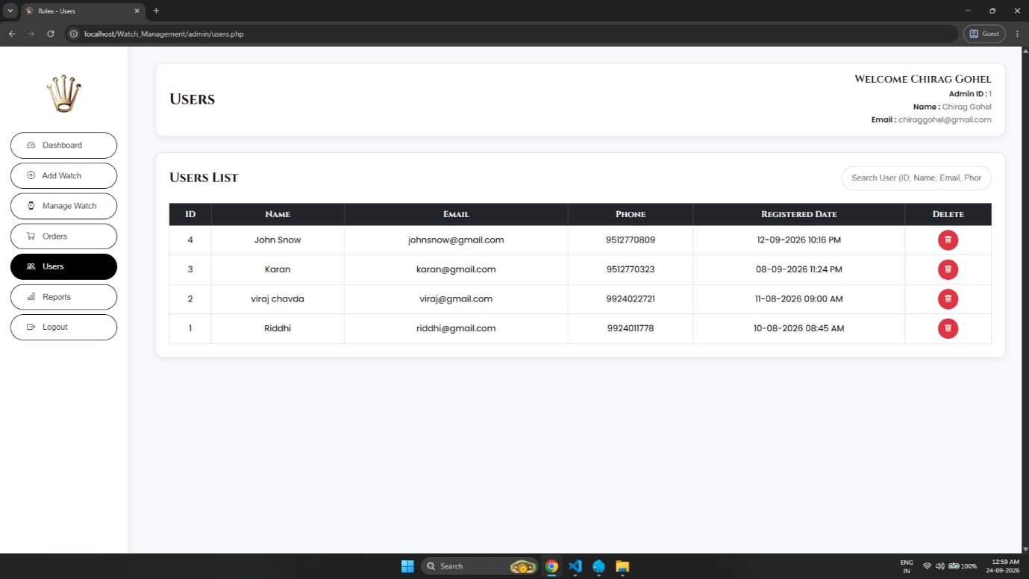

- This module displays a structured list of all registered users in the system, showing their User ID, Full Name, Email Address, Contact Number, and Registration Date.
- It provides search functionality to find specific users along with an administrative option to delete user accounts if required.

23. Reports Page (reports.php) :
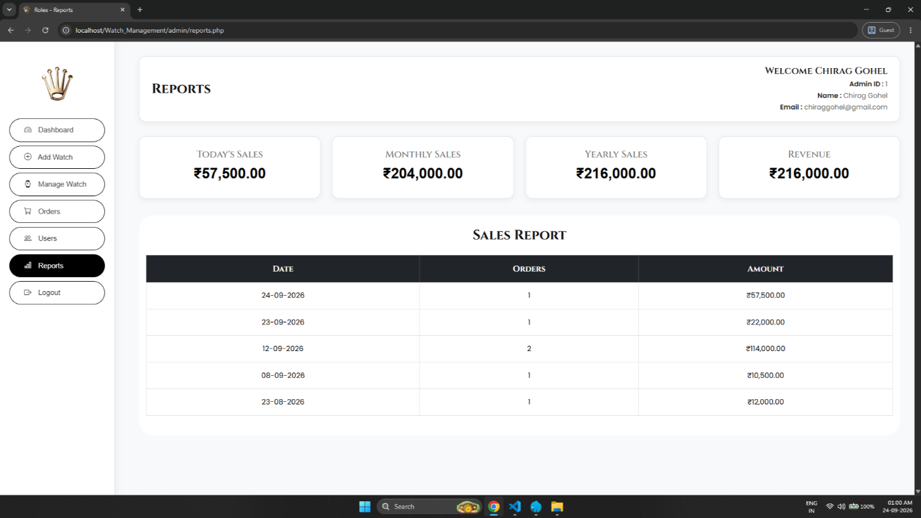
- This analytics screen highlights key sales metrics through summary cards showing Today's Sales, Monthly Sales, Yearly Sales, and Total Revenue.
- It presents a detailed 'Sales Report' data table displaying order counts and total monetary amounts categorized by specific dates.
24. About Us Page (about.php) :
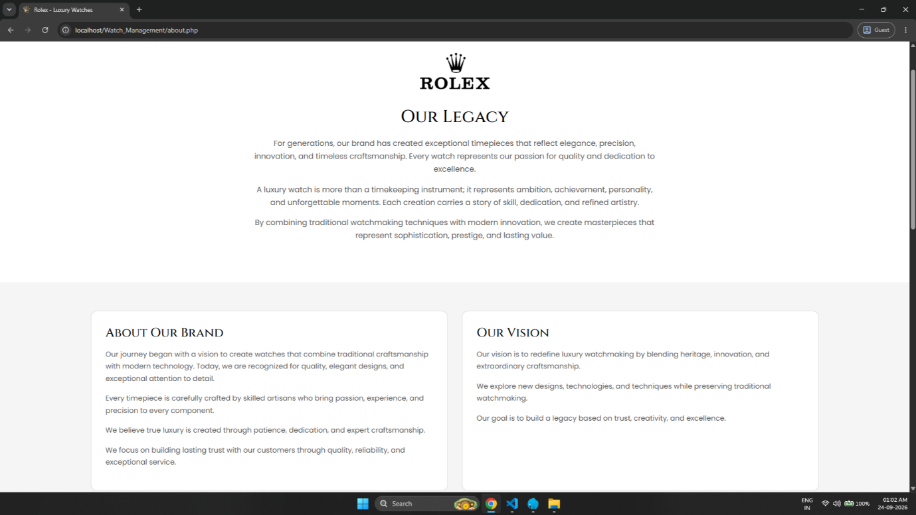
- This is the My Profile page displaying the logged-in user's personal account information, including name, email address, phone number, and membership date.
- It provides quick navigation buttons to update profile details, view order history, return home, or safely log out of the system.

Test Case

User Side

Test Case | Description | Actual Output | Test Result
Register Page | New user can register with name, email, phone and password. | New user can successfully register with name, email, phone and password. | Pass
Login Page | Registered user can login using email and password. | Registered user can successfully login using email and password. | Pass
Home Page | Display Featured Collection and New Arrivals watches. | Display Featured Collection and New Arrivals watches. | Pass
Products Page | Display all watches with Filter, Search and Category (case material, case size, dial color, watch resistance)options. | Display all watches with Filter, Search and Category (case material, case size, dial color, watch resistance) options. | Pass
Filter & Search | User can filter and search watches by name and category. | User can filter and search watches by name and category. | Pass
Product Details Page | Display selected watch details along with available stock and quantity option. | Display selected watch details along with available stock and quantity option. | Pass
Add to Cart | User can add watches to cart with selected quantity. | User can add watch to cart with selected quantity. | Pass
Cart Page | Display all added watches with option to remove item or proceed to checkout. | Display all added watches with option to remove item or proceed to checkout. | Pass
Remove Item From Cart | This button lets user remove any item from the cart. | This button lets user remove any item from the cart. | Pass
Checkout Page | User can add delivery address and view order summary. | User can add delivery address and view order summary. | Pass
Payment Page | Display available payment option (COD) to confirm the order. | Display available payment option (COD) to confirm the order. | Pass
Order Confirmation Page | Display "Order Placed Successfully" message with order details. | Display "Order Placed Successfully" message with order details. | Pass
My Orders Page | Display list of all orders placed by the user. | Display list of all orders placed by the user. | Pass
Order Details Page | Display detailed information of the selected order. | Display detailed information of the selected order. | Pass
Invoice Page | Display invoice of the selected order. | Display invoice of the selected order. | Pass
Print Invoice | User can print the invoice of the order. | User can print the invoice of the order. | Pass
Profile Page | User can view and update profile details (username, email, phone). | User can view and update profile details (username, email, phone). | Pass
Premium Badge | Display Premium Customer badge for users with account older than 1 month or with more orders. | Display Premium Customer badge for eligible users. | Pass
Contact Page | User can send a message through contact form (name, email, subject, message). | User can send a message through contact form (name, email, subject, message). | Pass

Admin Side

Test Case | Description | Actual Output | Test Result
Admin Login | Valid credentials should allow admin to log in directly to dashboard | Admin is redirected to Dashboard on entering correct email/password | Pass
Admin Login (Invalid) | Invalid credentials should not allow login | Error message shown, login denied | Pass
Dashboard Screen | Display admin name, id, email, total users, total orders, total watches, revenue, and recent orders | Display admin name, id, email, total users, total orders, total watches, revenue, and recent orders | Pass
Add Watch | Admin can add a new watch by filling required details | New watch is added and reflected in Manage Watch list | Pass
Manage Watch (View) | Display all watches in table format with image, name, price, stock | Display all watches in table format with image, name, price, stock | Pass
Update Watch | Clicking pencil/edit icon allows admin to update watch details | Watch details successfully updated in database | Pass
Delete Watch | Clicking delete icon removes the watch | Selected watch removed from Manage Watch list | Pass
Orders Screen | Display all orders with search and filter option | Display all orders with search and filter option | Pass
Order Status Update | Admin can update order status (Pending → Shipped → Delivered) | Order status successfully updated and reflected on user side | Pass
Order View Details | Clicking view button shows order, user and product details | Clicking view button shows order, user and product details | Pass
Users Screen | Display all registered users with search option | Display all registered users with search option | Pass
Delete User | Admin can delete a user from the list | Selected user removed from Users list | Pass
Reports Screen | Display today's sales, monthly sales, yearly sales, revenue and sales report | Display today's sales, monthly sales, yearly sales, revenue and sales report | Pass
Stock Auto Update | Stock should automatically decrease when an order is placed | Stock quantity automatically reduced after order placement | Pass

Limitation
Though We Tried Our Best In Developing This System But As Limitations Are Major Parts Of Any System So Are Of Our System. Some Limitations Of Watch Management System Are As Under:
- Only Cash On Delivery (COD) Payment Option Is Available; Online Payment Gateway (Card/UPI/Net Banking) Is Not Integrated.
- Real-Time Order Tracking (Live Shipment Status With Courier) Is Not Available.
- The System Does Not Support Multiple Product Images Or 360° Product View For Watches.
- There Is No Wishlist Feature For Users To Save Products For Later.
- The System Does Not Send Automated Email/SMS Notifications For Order Confirmation Or Status Updates.
- No Rating & Review System Is Available For Customers To Review Purchased Watches.
- The Admin Panel Does Not Provide Advanced Analytics Or Graphical Charts For Sales Reports.
- Data Load Speed May Be Slow When Handling A Large Number Of Products Or Orders.
- No Multi-Language Or Multi-Currency Support Is Provided.
- The System Does Not Have A Return/Refund Management Module.

Future Enhancement
To Conclude, this Watch Management System works like a complete platform which handles product listing, order processing and user management efficiently. Trying to remove the current limitations, some functionality that can be added in future is shown below.
- Add Multiple Payment Gateway Options (Credit/Debit Card, UPI, Net Banking, Wallet) Along With COD.
- Implement Email & SMS Notification System For Order Confirmation, Shipping Updates And Delivery Status.
- Add Product Review & Rating System So Customers Can Give Feedback On Purchased Watches.
- Add Wishlist Feature So Users Can Save Watches For Later Purchase.
- Implement Real-Time Order Tracking With Live Status Updates.
- Add Advanced Analytics Dashboard For Admin With Graphical Reports (Charts For Sales Trend, Best Selling Products, Customer Growth).
- Add Discount Coupon & Offer Management System For Promotional Sales.
- Implement Return & Refund Management Module For Customer Order Issues.
- Add Multi-Language Support To Reach Wider Customer Base.
- Convert The Website Into A Fully Functional Mobile Application For Android & iOS.
- Add Chatbot Or Live Chat Support For Instant Customer Query Resolution.
- Implement Stock Alert System To Notify Admin When Watch Stock Goes Below A Threshold Level.

Webliography
✓ https://www.w3schools.com/
✓ https://www.php.net/
✓ https://dev.mysql.com/doc/
✓ https://developer.mozilla.org/
✓ https://stackoverflow.com/
✓ https://api.jquery.com/
✓ https://www.geeksforgeeks.org/
✓ https://www.tutorialspoint.com/

